American International University-Bangladesh (AIUB)

Department of Computer Science

Faculty of Science & Technology (FST)

Spring 21-22

Section: B

Software Quality Assurance and Testing

Parental Security Application

A Report submitted

By

| SN | Student Name | Student ID |
| --- | --- | --- |
| 1 | Rashedul Haque | 19-39431-1 |
| 2 | Md. Zunayed Hossain Saafin | 19-39304-1 |
| 3 | Insana Marium Methela | 19-39411-1 |
| 4 | Tahsin Adiba Nijum | 19-40428-1 |

Under the supervision of

Abhijit Bhowmik

Associate Professor

Software Test Plan

for

Parental Security Application

Version 1.0 approved

Prepared by Md. Zunayed Hossain Saafin, Rashedul Haque, Insana Marium Methela,Tahsin Adiba Nijum.

Department of Science and Technology

20/4/2022

**Table Of Content**

**Revision History** **7**

**1. TEST PLAN IDENTIFIER:RS-MTP01.3** **7**

**2. REFERENCES** **7**

**3. INTRODUCTION** **7**

**4. REQUIREMENT SPECIFICATION** 13

**5. FEATURES NOT TO BE TESTED** **14**

**6. TESTING APPROACH** **14**

7.  **TEST CASES/TEST ITEMS** **15**

**8. ITEM PASS/FAIL CRITERIA** **21**

**10. STAFFING AND TRAINING NEEDS** **22**

**11. RESPONSIBILITIES** **19**

**12. TESTING SCHEDULE 22**

**13. PLANNING RISKS AND CONTINGENCIES** **25**

**14. APPROVALS** **26**

# Revision History

| Revision | Date | Updated by | Update Comments |
| --- | --- | --- | --- |
| 1 | 19-April-22 | Rashed | First Draft |
| 2 | 20-April-22 | Saafin | Second Draft |
| 3 | 21-April-22 | Nijum | Third Draft |
| 4 | 22-April-22 | Methela | Fourth Draft |

# 1. TEST PLAN IDENTIFIER:RS-MTP01.3

# 2. REFERENCES

1. Adobe Illustrator CC 2022: [www.adobe.com/products/illustrator.html](http://www.adobe.com/products/illustrator.html)
2. Monday.com : [www.monday.com](http://www.monday.com)
3. Selenium: [www.selenium.com](http://www.selenium.com)

# 3. INTRODUCTION

## Background to the Problem

Caring for aging parents must be the priority of every child, regardless of how pre-occupied they may be. We should make more effort to build a truly caring society which was willing to help the needy and less fortunate, especially our senior citizens. The younger generation today must learn to appreciate their parents and make it a culture and priority to care for them as they age. However, there are some who tend to get so carried away with their career and family commitments that they neglect their duties. No matter how busy you are, children have a responsibility to take care of their elders.

## Solution to the Problem

In order to deal with this issue and make caring for our parents easier we present the tool 'Parental Security' with features to help maintain the daily needs, security and health of our elders.

List of features:

• Parents and children have registered accounts with information of their voter ID. Each parent's account has their daily routine/needs and medical reports.

• Users will receive push notification according to the schedule of the parent's important daily needs and medicines. Parents can signal their children after taking medicines by pressing a button. If he/she fails to do so their children will be warned and receive emergency alerts to assist the parents.

# 4. REQUIREMENT SPECIFICATION

# **4.1** System Features

# **1.Registration**

**Functional Requirements**

1.1 The software have registration option .The registration procedure is for child user in this system. Child will sign in to the software by doing registration. It will take personal information such as name, email address, Country.

1.2 A verification code will be send to email id for verify.

1.3 If the verification is not successful , the verification code will be provided again.

**Priority level:** High.

**Precondition:** A valid email address.

**2.Create Profile**

**Functional Requirements**

1.1 After sign in child user will create two profile .One is child user profile & another is parents user profile.

1.2 In both profile, name ,mobile number, valid nid number, age ,location is needed.

1.3 After creating the profile ,both profile will be connected.

**Priority level:** High.

**Precondition:** Registration & sign in.

**3.Schedule**

**Functional Requirements**

3.1 After creating the profile child will schedule parents routine.

3.2 In schedule section there will be many options of routine like , parents mealtime ,medicine, exercise time, any kinds of advise, & other important information.

**Priority level:** High

**Precondition:** Create profile .

**4.Notification**

**Functional Requirements**

4.1 Following the schedule , a notification alarm will be ringed to parents device by the softeware.it will be reminder for them to do their needed activities .

4.2 If they don’t response then automatically a notification will be shown to child profile .Then they will aware of it.

**Priority level:** High

**Precondition:** Schedule

**5.Update schedule & Information**

**Functional Requirements**

5.1 User will be able to update or change schedule anytime.

5.2User also can update other information like mail id ,phone number & etc .

**Priority level:** High

**Precondition:** Registration & schedule .

**6.1 Settings & Background Options**

**Functional Requirements**

6.1 In the software there will be settings option for change language & also theme mode option (Dark mode & Light mode).

**Priority level:**Low

**Precondition:** Registration & schedule .

## 

## **1.1** **System Quality Attributes**

## Non-Functional attributes

**Usability** :

The system shall be usable by only the senior citizens. The system must be easy to user

.**Priority level:** High.

**Flexibility** :

Flexibility is used as an attribute of various types of system .users can easily access and adapt the software so frequently to utilize their needs. The software is organized according to user demand and user easily understand the change.

**Priority level:** High.

**Integrity** :

Whenever a change is made to software or any activity from user will recorded in a secure storage and update the activity system through secure Connection.

**Priority level:** High.

**Efficiency :**

If the system is using all the available resources then the user will get degraded performance failing the system for efficiency. If the system is not efficient then it can’t be used in real-time applications. As the software will be mostly used by the senior citizen ,it is organized in small size so that it will be more efficient.

**Priority level:** High.

**Performance :**

Performance of software depends on software optimization. System management sector shall provide better quality database server, transaction and usage storage. They will keep the system out of unnecessary load.

**Priority level:** High.

**Reusability** :

System development should be in good sequence so that reuse of the software will be a good cost-efficient. Software implementation should be in different code library classes to use easily in different application modules. Dividing the application into different modules so that modules can be reused across the application.

**Priority level:** High.

**Portability** :

The System should be so simple transform one medium to another.

**Priority level:** Medium

**Testability :**

The system should be easy to test and find error. The system will be organized in a sequence to divide into different modules for testing.

**Priority level:** High.

**Maintainability** :

The system will be well documented and it will be designed to be easier maintenance. The system shall not be shut down for maintenance more than once in 24 hours. Maintenance should be cost-effective and easy.

**Priority level:** High.

**Insterface** :

All aspects of the system will have a simple point and click interface using text field, buttons, all other components of the system with graphical user interface. This interface will be designed to be consistent. The interface will be designed to help accommodate user with disabilities such as colour blindness. The system will also have clear and understandable message for every steps and activity.

**Priority level:** High

**4.3** System Interface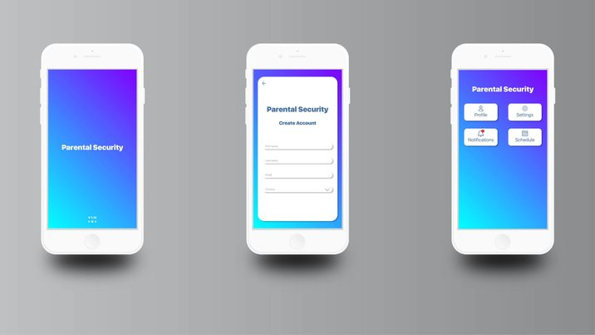

Fig 1: App UI/UX

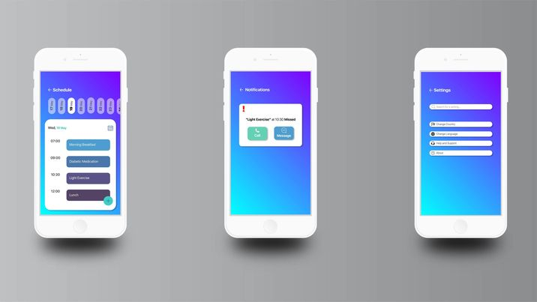

Fig 2: App UI/UX

## **4.4** Project Requirements

· Total Development Time: 6 months.

- Total Working Hours needed: 1440 Hours

- 10 * 8 * 18 = 1440 hours or 18 months for development

- 8 * 30 = 240 hours for Testing & Debugging

- 2 months for revision

· Total Budget: 1,450,000 BDT

· Resources: 4 app developers, 4 software testers, 4 Custom Built PCs, 5 Android mobile smartphones.

LAN Connection.

· Framework: Flutter

· Language: Dart

. Database:MongoDB

# 5. FEATURES NOT TO BE TESTED

# We have a total of ten features in our project. Out of these ten features, two will not be tested. Those two features are:

**1.** **Profile Edit:** All the vital information will be cross-checked at the time of registration. So, this is not an essential feature. There will be some functions in profile edit like upload & change the user’s profile picture and change the app’s theme. Without these things, one can easily use the app.

**2.** **Multi-language:** By default, the language will be English. We have conducted a survey, most of the participants preferred English as their preferred language for the app. In this way, foreigners can also use the app. Nevertheless, many people preferred Bangla as the app language, so we will work on that. However, this is not a high-prioritised feature. We will not test this feature as of now.

# 6. TESTING APPROACH

## **1.1** Testing Levels

# The ‘Parental Security Application’ testing will consist of Unit, System, Integration, and Acceptance test levels. However, with the budget constraints and timeline established, most testing will be done by the test manager with the development teams’ participation.

# · **Unit Testing:** Unit testing means individual testing, and it is also white box testing. When a developer completes a module, the developer compiles that module to ensure the module is working. In our system, this testing will occur when a developer completes the design of any page.

# 

# **Control Flow Testing:** It aims to find defects caused by the faulty construction of program code. It is white box testing. In our system, the developer will select a particular part of an extensive program to set the testing path and Test cases represented by the control graph of the program. Control Flow Graph (CFG) is formed from the nodes & edges.

# 

# **Data Flow Testing:** In this testing, data has been traced, and the main goal is to find out the anomalies of the program. In our system, the developer will search for anomalies (Defined and then defined again, Undefined but referenced, defined but not referenced). If the developer finds any anomalies, they will detect them and try to solve them.

# 

# **Domain Testing:** The primary goal of domain testing is to check whether the software application accepts inputs within the acceptable range and delivers the required output. In our system, the developer will identify domains from the source code. First of all, a developer will draw a control flow graph from the given source code. Then find all possible interpretations of the predicates. Furthermore, at last, analyse the interpreted predicates to identify domains.

# 

# · **Integration Testing:** Integration testing aims to check the correctness of communication among all the modules. It is performed by the test manager and development team leader with assistance from the individual developers as required. When developers develop two or more modules in our system, the testing team will join these modules and check the incompatibility.

# 

# · **System Testing:** This testing occurs when the integration testing has been done. Here it tests the overall system operations as a whole, typically from a customer’s perspective. It is black-box testing. In our system, the tester team will combine the whole system (software and hardware). Then compile the entire system, and if they got any problem, they would fix it as soon as possible.

# 

# · **Acceptance Testing:** It is formal testing. This testing phase verifies the entire illness of the customer’s requirement. The Customer/end-user will test the whole system and will give feedback.

# 

## **6.2** Test Tools

The tools have different approaches to testing and thus have different sets of features. We will use flutter and Mongodbto develop our application.

### 1.1.1 Unit Testing

Unit testing is a type of testing in which individual units or functions of software testing. Its primary purpose is to test each unit or function. A unit is the smallest testable part of an application. It mainly has one or a few inputs and produces a single output.

· For dart, we must need SELENIUM as a software testing tool.

### 1.1.2 Integration Testing

Integration testing is a type of testing meant to check the combinations of different units and their interactions; subsystems unite into one standard system and code compliance with the requirements.

For integration testing, we must use selenium as our testing tools. This tools are for web.

### 1.1.3 System Testing

System testing verifies that an application performs tasks as designed. This step, a kind of black-box testing, focuses on the functionality of an application. System testing, for example, might check that every type of user input produces the intended output across the application.

To perform System testing, we will use:

· **Selenium:** Selenium is Codeless Automation Testing Tool that provides automated testing solutions to test our website. Selenium Automates executes and manages test cases effortlessly & efficiently.

·

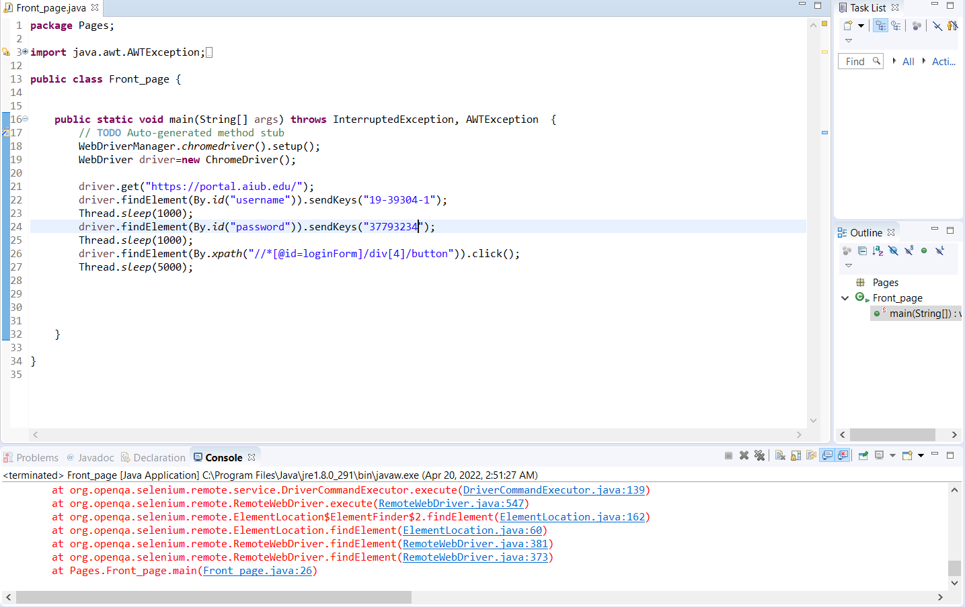

Fig 3: Selenium testing

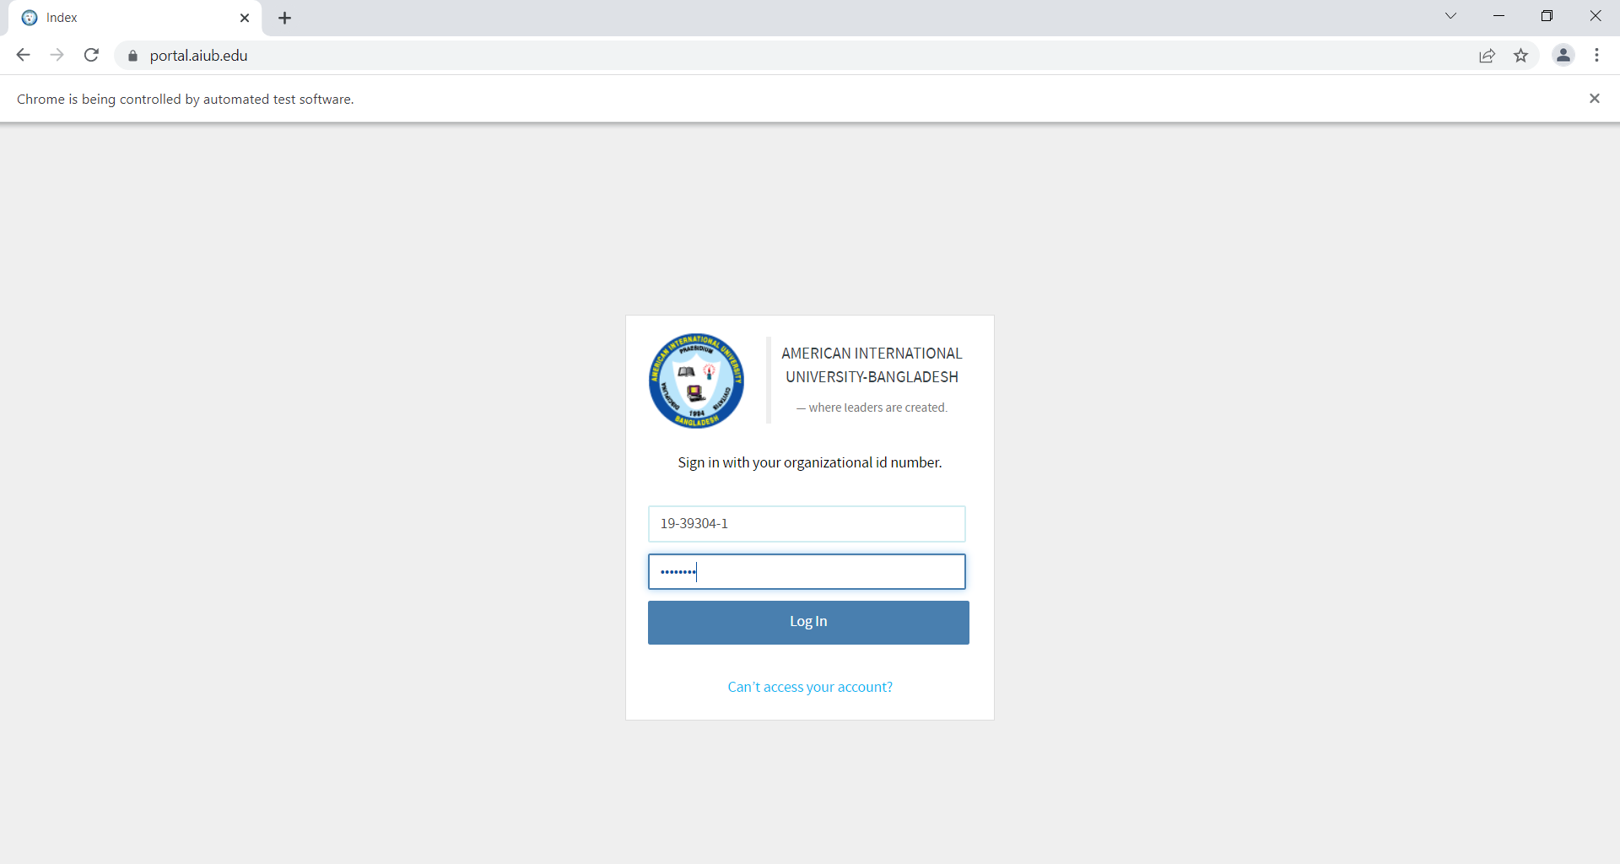

Fig 4: Selenium testing

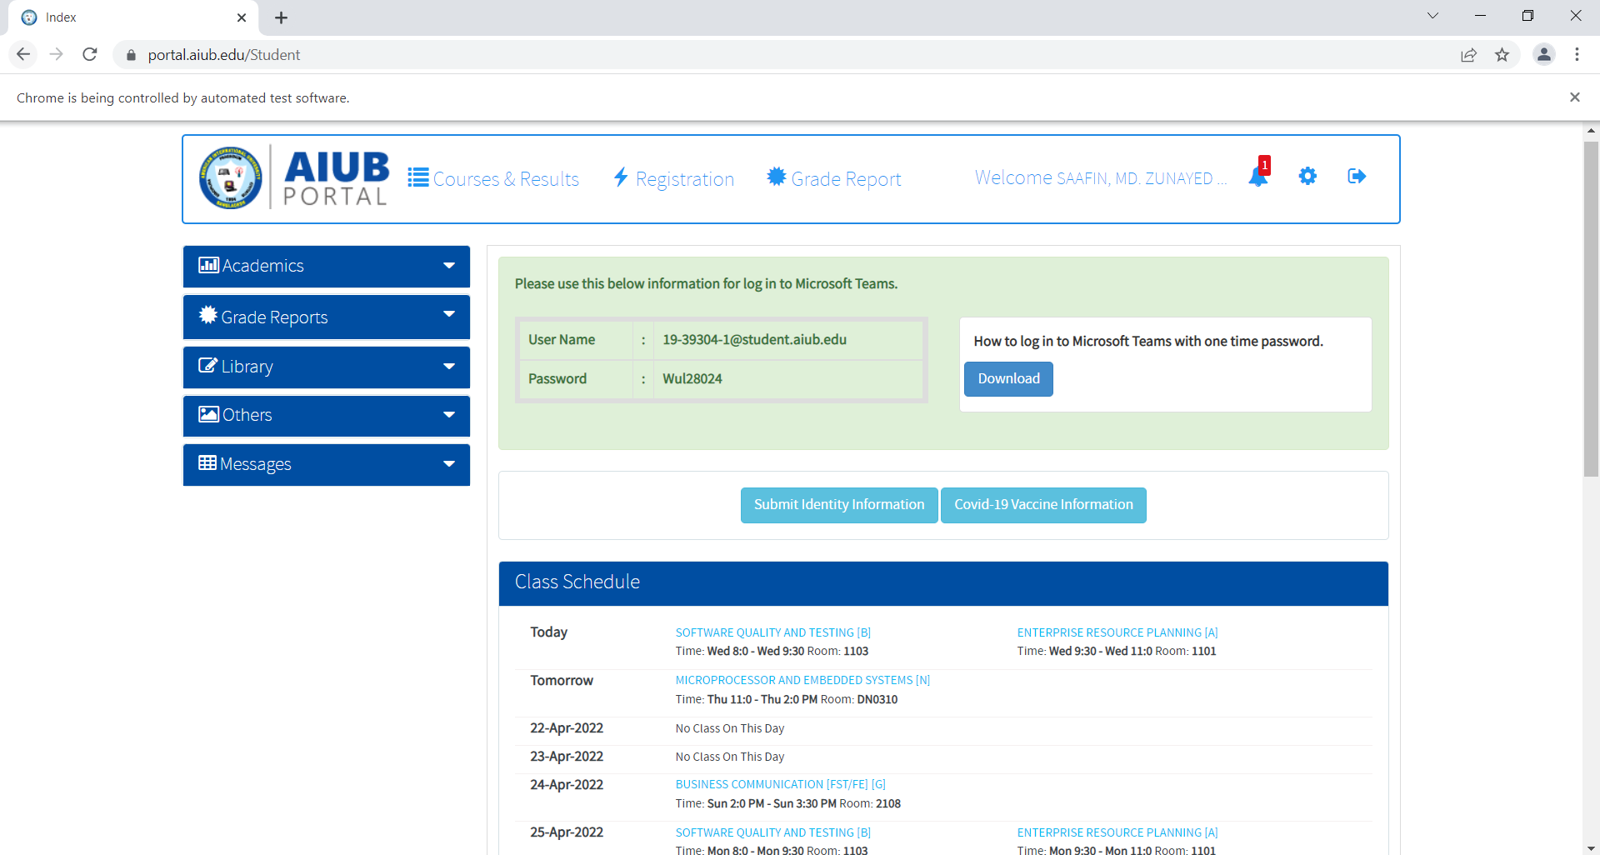

Fig 5: Selenium testing

## **6.3** Meetings

This entire project duration is 24 weeks, and the testing phase will take 46 days. During this time, we have about 7 weeks.

· All modules will be tested in the first 4 weeks by unit testing, integration testing, & system testing. The whole testing phase will occur in this period by the QA Engineers. If they have any defect, they will solve it and again test the entire module.

·It will take two weeks for a customer or third-party test. In this phase, acceptance testing will occur. They will test the system and give us a review report.

·When the review report comes from the vendor and if there is any defect, the review report will be looked up and analyzed to solve the fault. It will take one week to solve the problems and go for final testing.

· A general meeting will occur every Friday at 10:00 PM.

7. TEST CASES/TEST ITEMS

| Project Name: Parental Security | | | Test Designed by: Saafin | | |
| --- | --- | --- | --- | --- | --- |
| Test Case ID: AN0001 | | | Test Designed date: 20/4/22 | | |
| Test Priority: High | | | Test Executed by: Saafin | | |
| Module Name: Registration | | | Test Execution date: 20/4/22 | | |
| Test Title: Registration Verification | | |  | | |
| Description: Security code and verify the email id. | | |
| Precondition (If any): 1. If the email id is valid. | | | | | |
| Test Steps | Test Data | Expected Results | | Actual  Results | Status  (Pass/Fail) |
| 1.Verify Id by code | Email id :  Name: Rabby | Give confirmation | | As expected | pass |
| Post Condition: The system will allow for further step. | | | | | |
|  |  |  |  |  |  |

| Project Name : Parental Security | | | Test Designed by: Rashed | | |
| --- | --- | --- | --- | --- | --- |
| Test Case ID: AR00200 | | | Test Designed date: 20/4/22 | | |
| Test Priority: High | | | Test Executed by: Rashed | | |
| Module Name: Schedule | | | Test Execution date: 20/4/22 | | |
| Test Title: Check the selected schedule | | |  | | |
| Description: Verify the users routine. | | |
| Precondition (If any): Schedule must be organized. | | | | | |
| Test Steps | Test Data | Expected Results | | Actual  Results | Status  (Pass/Fail) |
| 1. See all schedule  2. Select preferable routine | Schedule :      Morning medicine | Should see the schedule | | As expected | pass |
| Post Condition: The system will allow for further step. | | | | | |
|  |  |  |  |  |  |

| Project Name: Parental Security | | | Test Designed by: Nijhum | | |
| --- | --- | --- | --- | --- | --- |
| Test Case ID: AR00201 | | | Test Designed date: 20/4/22 | | |
| Test Priority: High | | | Test Executed by: Nijhum | | |
| Module Name: Notification Alarm | | | Test Execution date: 20/4/22 | | |
| Test Title: Verification of Timely Notification | | |  | | |
| Description: Check that does the notification follow the routine . | | |  | | |
| Precondition (If any): Routine time must be organised. | | | | | |
| Test Steps | Test Data | Expected Results | | Actual  Results | Status  (Pass/Fail) |
| 1.Verify Child profile notification  2.Verify Parent  Profile notification | Schedule Data:  23289240923 | Notification alarm  must give alerts. | | As expected | Pass |
| Post Condition: Show the notification | | | | | |

# 8. ITEM PASS/FAIL CRITERIA

Whether an item has passed or failed will be evaluated in 3 ways.

**1.** **Evaluation team:** Evaluation team will look after each Items condition. In this subsection, by whom the items will be checked are:

· UAT (User Acceptance Testing) Manager

· UAT Analyst

· Project Sponsor

· A representative of the Development Team

**2.** **Exit Criteria:** In this subsection, the following conditions will be checked:

· All code completed and frozen, and no modules to be integrated.

· 100% system integration tests passed

· No major defect is found.

· All the moderate defects found in SIT (System Integration Testing) phase have been fixed and re-tested.

· Not more than 10 minor defects are outstanding.

· Two weeks system uptime in system integration test environment without any anomalies.

· System integration tests are documented.

**3.** **Evaluation Process:** This sub-section on the 8.3 Evaluation Process describes a four-stage process for systematically evaluating the testing results to decide whether the test item has passed or failed. The stages are:

· **Summarize Testing Results**: All open or closed incidents will be traced to a Requirements Traceability Matrix requirement.

· **Evaluate Business Scenarios:** Each open Incident - and closed Incident, if agreed it is appropriate - is traced back to the Business Scenarios. An assessment is made about the technical impact and whether they can deliver the functionality the organization needs.

· **Estimate Business Impact:** Each open Incident is then checked to see its impact on the organization. The effect, frequency of business impact, and countermeasures such as fix schedule and workarounds are analyzed and recorded.

· **Make Acceptance Decision:** The analyses are then evaluated as to the acceptance decision. This acceptance can be one of:

§ **Full Acceptance:** The system will be accepted as is. Any outstanding Incidents will be worked around.

§ **Limited System Acceptance:** The outstanding Incidents cause too many problems. The system is accepted subject to a timetable of fixes, staff training about workarounds, and similar measures.

§ **System Rejection:** This is where the system does not support the Business Scenarios of the organization.

9. TEST DELIVERABLES

· Test Plan: This document deals with what needs to be done in UAT.

· Designs: The UAT Acceptance Criteria.

· Test Cases: The values input and results expected from tests.

· Test Item Transmittal Reports: Developers handover report.

· Test Logs: The results of running the tests.

· Incident Reports: Observations of unexpected results.

· Incident Report Logs: Summary of Incident Reports.

· Test Summary Report: Summary of testing.

· The test data.

# 10. STAFFING AND TRAINING NEEDS

* The developers and testers will need to be trained on the basic operations of the mobile application.
* The sales administration staff will require training on the new screens and reports.
* At least one developer and operations staff member must be trained on the mobile-based distributors installation and control.

# 11. RESPONSIBILITIES

# 

# 

| Name | Role | Responsibilities |
| --- | --- | --- |
| Rashedul Rabby | Project Manager | 1. Determines which of the identified problems must be solved and in what order.2. Review all open reports each week, identifying the problems of interaction3. Obtain the necessary literature to find deficient information about any problem. |
| Md. Zunayed Hossain Saafin | Test Lead | 1. Defining the testing activities, All responsibilities of test planning2. To check if the term has all the necessary resources to execute the testing activities.3. Prepare the report of testing activities.4. Updating project managers regularly about the progress of testing activities. |
| Tahsin Adiba Nijum | Test Engineer | 1. Develop test cases and prioritize testing activities.2. Execute all the test cases and report defects.3. Inform the test lead about what all resources will be required for software testing. |
| Insana Marium Methela | Software Tester | 1. Designing testing scenarios for testing.2. Perform the testing.3.Create testing documentation and does testing-related work. |
| Md. Zunayed Hossain Saafin | Software Tester | 1. Creation of test designs, test processes, test cases, and test data.2. Carry out testing as per the defined procedures.3. Prepare all reports related to software testing carried out. |

12. TESTING SCHEDULE

The following testing activities have been scheduled in the project plan. We have used the cloud based platform “Monday.com” to create a gantt chart for our project schedule. The project plan timetable specifies the particular dates and hours for each task. In collaboration with the development and test team leaders, the project manager will coordinate the employees required for each task, test team, development team, management, and customer.

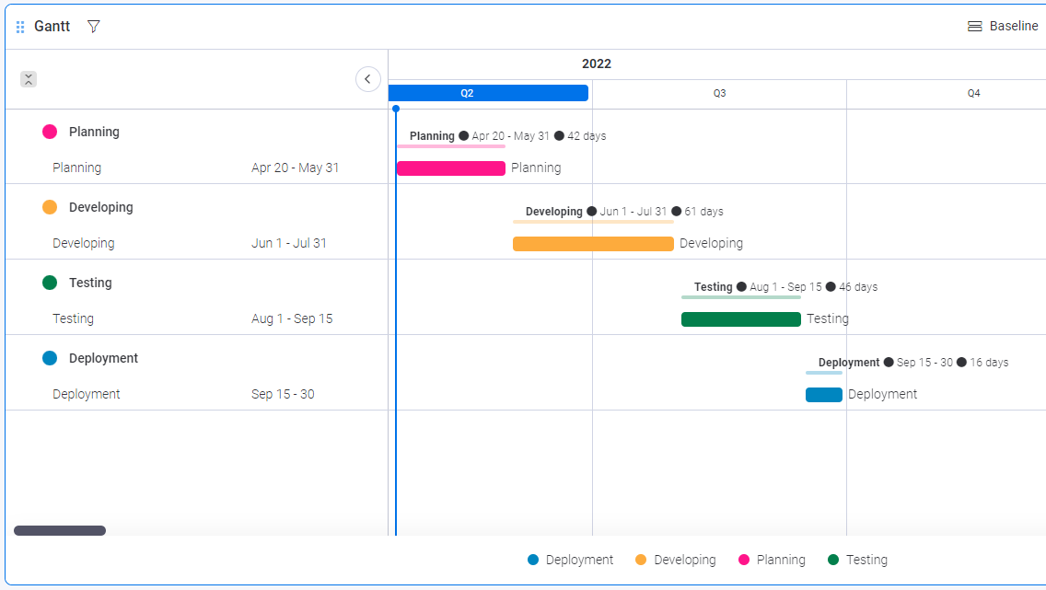

Fig 6: Gantt chart for project schedule

# 13. PLANNING RISKS AND CONTINGENCIES

| Risk | Probability | Impact | Mitigation |
| --- | --- | --- | --- |
| Error in Functions | Medium | Medium | Test the application frequently and maintain a daily backup. |
| Wrong SQL Command for Important Data | Medium | High | Maintain security checks & backups. |
| Loss of encrypted data | Medium | High | Maintain security check and backup. |
| User’s account hacking attempt | High | High | Restrict user after three unsuccessful login attempts in an hour. |

# 14. APPROVALS

| **Position** | **Assigned** |
| --- | --- |
| Project Sponsor | Md. Zunayed Hossain Saafin |
| Development Management | Tahsin Adiba Nijum |
| EDI Project Manager | Tahsin Adiba Nijum |
| RS Test Manager | Rashedul Haque |
| RS Development Team Manager | Md. Zunayed Hossain Saafin |
| Reassigned Sales | Insana Mariam Methela |
| Order Entry EDI Team Manager | Rashedul Haque |

# 